Projectiles - Questions
June 2015 Mathematics Advanced Paper 1: Mechanics 1

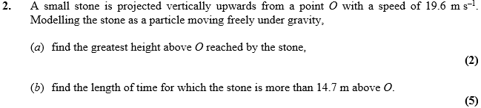

May 2012 Mathematics Advanced Paper 1: Mechanics 1

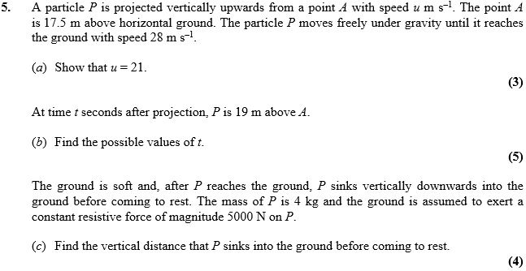

Jan 2012 Mathematics Advanced Paper 1: Mechanics 1

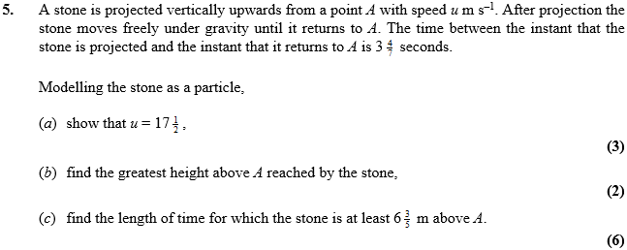

May 2011 Mathematics Advanced Paper 1: Mechanics 1

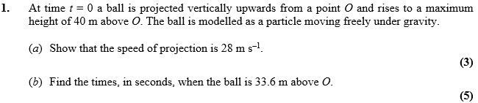

Jan 2011 Mathematics Advanced Paper 1: Mechanics 1

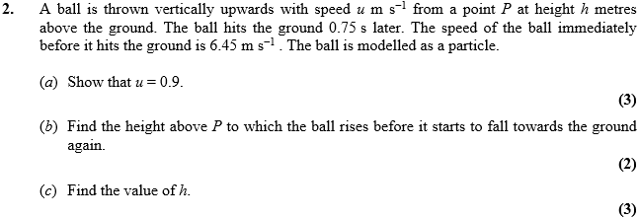
May 2010 Mathematics Advanced Paper 1: Mechanics 1

